

Nathan Cohen

Studomatic (Patent Pending)

SDD Major Project 2014/15

Table of Contents

Identifying the Problem 3

Development Approach 3

Major Project Logbook 3

Gantt Chart 9

Data Dictionary 10

Quality Assurance 11

Hardware Design 12

IPO Chart 13

Social and Ethical Issues 13

Storyboard 14

Test Data & Expected Output 14

DFD 15

System Flowchart 16

Structure Chart 17

Context Diagram 18

Reflection 19

Identifying the Problem

Everyday approximately 3,645,519 children go to schools around Australia. Before this project all of these students attendance would have had to be manually recorded by a teacher or other member of staff wasting time, personnel and resources – no longer. My project is to completely re-imagine the way this is done and subvert the roles. The functionality requirements of this system would be

* The need for minimal staff interaction
* Minimal recourses
* Minimal time spent signing in
* Over 300 non concurrent users on one system
* The ability to have multiple systems working at the same time

To put these requirements in short this system essentially needs a fast way of identifying students, verifying their credentials and storing it somewhere. My project will do exactly this with the use of RFID/NFC to identify students and gather their credentials, a raspberry Pi to quickly, concisely and efficiently store this data and concurrently send it to a database and a touch screen for ease of use for administrators and students a like. In addition to this functionality, this system will also be capable of interfacing with an online student timetable and displaying it without the need for a lengthy login process again by just the tap of a card. This system as a wholes requirement is:

* 240V Wall outlet Power
* Internet connection via Ethernet cable

For just the software the requirements are:

* Raspberry Pi (Or Linux OS with UART interface and libnfc library)
* GUI
* 256Mb Ram
* 16gb Storage

I plan on having the whole system incased in a 3D modeled and printed plastic case that can be attached to any wall via screws.

Development Approach

As this project will be extremely dynamic in terms of the design phase and even to some extent the planning phase I needed a development approach that would allow for some leeway in terms of design. At the same time as this I needed an approach that would structure precisely the wa and timing of which each step in my project would be completed. Thus I came to the conclusion I would use a mixture of the Agile approach and the Structured approach. This development approach suites me as there is obviously only one person in the development team, and while structured does not suite this, agile does. In addition I need to keep up a fair amount of dialogue with my clients again Agile allows for and structured to a lesser extent. Overall this approach does fit all fo the needs and properties of this project and thus it will be the approach I’m using.

Major Project Logbook

20/10/2014

Today we got the notification of the first part of our assessment task. This first part, defining and understanding the problem, is probably the most finicky and seemingly most useless part of the major project assessment. But in terms of the Software Design and Development timeline it is almost the most important. Although in many Software design approaches, the defining stage is fairly unimportant – including rad, agile and prototyping but in the approach I am using, a custom mixture of structured and agile, the defining stage is extremely important if not fundamental part of my project.

23/10/2014

This week has mostly been a week for considering considerations for the design phase of my software major project. The considerations I made include:

* The Design Approach
  + I have swapped a few times between Structured, Agile and a mixture of the two as well as the prototyping approach. I am still considering which to do and will have to look further into how they will affect the timeline of my project overall
* The language I would be using
  + I’m fairly sure my project will use Python, but to interface with the hardware of my project I may need to dabble in C++ and or lower level languages.

These two parts of my project are probably some of the most important of my whole project and will probably have to be considered and contemplated for the remainder of this part of the assessment

27/10/2014

This is the second week that we have had this first part of our assessment task. The defining stage of our assessment overall includes taking into account the perspectives of the User and the Developers from opposing perspectives. My idea, being a student management system aimed at my own school, is fairly easy to know the specifications of. Even taking this into account I still need to contact users – students, teachers, etc… to find out the exact specifications of what they want and how they want to be able to use it. I will start this communication at some point in the future but for now I will contemplate the specifications that I have defined myself as the user and developer

29/10/2014

Today I solely thought about how my hardware will work and and how the components will work together. The Hardware I will be using consists of:

* 7” Touch Screen
* Raspberry Pi (128Mb)
* RFID/NFC Card

The Touch screen interfaces with the Raspberry Pi through a graphics board and an HDMI cable. The Raspberry Pi interfaces with NFC/RFID card via IO ports

3/11/2014

Today was a fairly un-productive day for me in terms of my project. I have attempted to get the Gantt chart creator I have previously used working but apparently IT has decided my computer isn’t to run Java. This problem will take a fairly long while to fix if my experience has told me anything but I can’t be sure as of yet.

6/11/2014

Today I enquired with teachers as to what they thought of my project and what features they would want if this new system was to be implemented. This dialogue didn’t go very in depth but it did still give me insight into what people really liked and what they didn’t like so much.   
  
As well as this today I started on some of the harder documentation today Including System Flowcharts, Structure Charts and Data flow diagrams

10/11/2014

Today I have contemplated putting up a survey onto social media so as to start more dialogues on features and functionality that people want and would use. The survey would only have 5 or 6 questions but would ask if my project is really needed and what about it its needed the most.

Additionally to this I have started to contact people about 3d modeling a case to be 3d printed and used for my project. So far I have only talked to one person but they have expressed interest in helping me with this project.

13/11/2014

Today was an extremely productive one. I have started and finished work on the following elements of my project:

* Storyboard
* Data Dictionary
* System Flowchart

Although these parts are finished they made need some sort of revision at some point due to changing needs and the dynamic nature of the way I think about problems.

In addition to this, recently I have been given all the needed parts of hardware to get my project running, so today I drew up a plan of how I am to connect all of these elements in an efficient and practical manner. Unfortunately this also raised a few issues to my attention including my lack of knowledge in the field of soldering and my deficit of breadboards, wires and power supply’s.

17/11/2014

As the due date for this part of my assessment gets closer, I have started devoting more time and effort into this assessment. Trying to gather more knowledge and know-how in terms of the hardware and similarly gathering information on how to write some of the documentation. The documentation in particular that I need help with is the stuff we haven’t done in previous years and have been taught little to nothing about including:

* Quality Assurance
* Identifying the Problem
* User Feedback
* Test Data & Expected Output

Although ‘Identifying the Problem’ and ‘User Feedback’ are fairly self-explanatory which has made it exponentially easier to construct these myself. By fair the factor that makes it the hardest to learn about these elements of documentation is that we are going on with mostly irrelevant course work in class, which is fair enough, but indeed it does not help to complete a Quality Assurance criteria when we are learning about exponential, linear, hyperbolic, etc time.

20/11/2014

Finally I have created a working model of my project! And by working I mean the green light stays on for longer then 3 seconds and by project I mean the RFID/NFC module, although it won’t be properly working until I can solder the wires into the module and get the API/Library/Binaries to compile and work properly. Furthermore today I was able to get a start on some of my Quality Assurance criteria, after many periods of inconspicuously searching the internet for examples of Quality Assurance criteria I found a few useable recourses. Unfortunately for me these recourses got me nowhere in the eyes of our assessment, giving me only code tests I already knew of including but not limited to:

* Rubber duck checking (my personal favorite)
* Speed tests
* Peer Checking
* Code Criteria
  + Casing
  + Commenting (Intrinsic and explicit)
  + Sub routine length limiting

Additionally to the problem that these are only a small number of tests, they only apply to the code and as such give me no ability to test my system as a whole and other parts that are more user orientated.

24/11/2014

Today I finally decided to publish a survey, using Google forms, I constructed a 6 question survey that attempted to prove there is a need for my project and then find the specific features people liked best. Here are the specific questions:

**1. What is your role in Emanuel School?*Required**

* Student
* Teacher
* Admin Staff
* Other:

**2. What Time Do You Get To School Each Day?\***

**3. Do You Catch The School Bus?\*** 

* Yes
* No

**Do You Think There Is A Problem With Our Current Attendance System?*Required**

* Yes
* No

**If You Answered Yes To The Last Question, Please Expand On Said Problems.*Required**

**Do You Think We Need A New Attendance System?**

* Yes
* No

**What Would You Like To See In A New Attendance System?*Required**

**Do You Use Edumate To Check Your Calendar?*Required**

* Yes
* No

**Do You Like The Idea Of An Opal Card Style Attendance System*Required**

* Yes
* No

**Would You Use Edumate More If You Could Check Your Calendar Using Your Opal Style Card At A Computer Around The School?*Required**

* Yes
* No

As is quite plain to see this survey goes about, quite bluntly, answering the questions I want to know. Hopefully soon enough I will know of the answers to this survey. It’s interesting to note that, in my mind, the point of the survey is more to cement the need for the product I have developed from a student point of view rather than a teacher and/or administrative point of view.

27/11/2014

This evening, in a vein attempt to relax, I have started to force the raspberry Pi I am in possession of to work. In short all this means is for the touch screen to work in a calibrated fashion, sensing a finger and moving the mouse accordingly from a relatively precise starting point. Unfortunately computers don’t really like me and so this did not happen, but rather at first the touch screen didn’t work at all. After fiddling with wires and power supplies for a while I finally had some idea of what was happening, I needed a driver to get this touch screen to interface properly with the Pi. I though this might happen so I was prepared and installed an program on a kernel level that is built to help the raspberry pi specifically interface with the touch screen I had purchased. At this point I would again like to note that computers really don’t like me and so, as could only happen to me, the program did not see the interface. This forced me to search around on the internet for a few hours whilst the raspberry Pi sat there and though about what it had done wrong, so as usual it sat there in an idle state. I think it’s interesting to comment that quite a few things have gone wrong with this set up that the website assured me wouldn’t with it’s introductory video:

* The power supply was not there and neither was the needed polarity
* The drivers were not noted down anywhere – on the internet or intrinsically
* The way the screen was to be physically connected, although fairly menial, was not noted ANYWHERE and so I had to guess and check almost as much as I do in 3 unit maths
* Lastly the only way of knowing whether the touch screen is working or not is this tiny green LED on the smallest power board you have ever seen

All in all this touch screen has been one of the biggest pains in this project so far.

1/12/2014

On a very fitting date, today was like an early Christmas for me. After sending the link for my survey to many a person, when I checked the responses this afternoon it seemed I had accumulated quite a few responses (20 in fact). These responses ranged from silly and not at all useful characters instead sentences to extremely constructive feedback. Bellow is a sample of some of the better responses:

|  |  |  |  |  |  |  |  |  |  |  |  |  |
| --- | --- | --- | --- | --- | --- | --- | --- | --- | --- | --- | --- | --- |
| Student | 8:40:00 AM | Yes | Yes | Too many kids are being too lazy and are not signing in at the office. | Just like at Sydney Boys, each student should have to swipe a card as they walk through the gates which will monitor on the school system what time kids arrive and leave school.  Each student should get assigned a card. | Yes | | | Yes | | Yes | Yes |
| Student | 7:45:00 AM | No | No | It's hard to tell really, I think the computer system stuffs up attendance too frequently though. | Something easy to follow and more reliable that doesn't say someone isn't here when they are | No | Yes | Yes | | Yes |
| Student | 8:00:00 AM | No | Yes | Occasionally, even though on an excursion students are marked as absent | An online way for students to give their reasons for not attending school or being late | Yes | Yes | Yes | | Yes |

As you can see these responses were actually useful and do I fact cement the need for the project I have created. Hopefully, as soon as Mr Drake sends my link to the teachers and Admin staff, I will get some more responses from a different, but still as important, demographic.

4/12/2014

Thankfully after looking around the vast expanse of the internet for a little while, I found a very nice German gentlemen who had developed a bootstrap/ XBMC application that interfaced with the touchscreen perfectly even though the program was originally built as an in car entertainment system. So after trimming the fat of his beautifully coded application I was able to get the touch screen display calibrated and working with Raspbians default IDE. This sets a very nice basis and creates a well needed proof of concept that will only be topped by the first working prototype of the much more finicky NFC/RFID module.

In addition to the hardware part of my project, which seems to have taken over my last few days, I have also finished off some of my design documentation including:

* Storyboards
* Development Approach
* User Feedback
* Log Book (Up to Date)
* IPO Diagrams
* Context Diagram
* Data Flow Diagram
* Structure Chart
* System Flowcharts
* Data Dictionary

The only pressing pieces of documentation are:

* Gantt Chart
* Social and Ethical Issues
* Test Data and Expected Output
* Identifying the Problem in it’s fullness
* Quality Assurance

8/12/2014

Today has been a fairly productive day, although I haven’t exactly done a lot. I am finalizing my documentation as the project is due at the end of this week and as such I have added the finishing touches to the following documentation:

* Social and Ethical Issues
* Development Approach
* Test Data and Expected Output
* Gantt Chart
* Data Dictionary

In addition to all of these I have finished off my Project website, uploading a zip file of all my documentation to said website. After this I then went on to survey more of my user feedback to find that I had a few more entries, which have only affirmed the need for a new system.

Gantt Chart

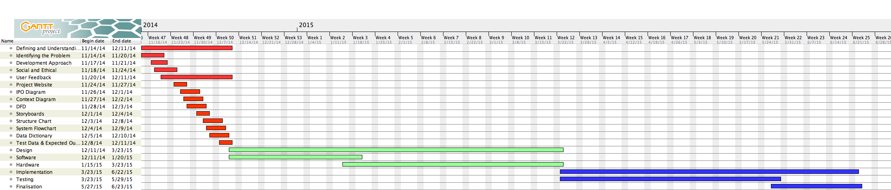

Data Dictionary

|  |  |  |  |  |  |
| --- | --- | --- | --- | --- | --- |
| **Field Name** | **Data Format** | **Data Type** | **Field Size** | **Description** | **Example** |
| Student ID | XXXXXXX | Integer | 17 - 20 Bits | Identification number to be scanned | 123456 |
| Admin ID | XXXXXXX | Integer | 17 - 20 Bits | Identification number to be scanned | 123456 |
| Raw Data (From Edumate) | {} | Array | Approx 400 *17-20 bits | Raw data from edumate displaying students logged | {} |
| Calendar (From Edumate) | {} | CSV | 1 Mb | Calendar data from edumate | {} |
| User Input | XX | Integer | 17 - 20 Bits | User input (based on GUI decision) | 3 |
| Response (Edumate) | T/F | Boolean | 1 byte | Login Pass or Fail response | Y |
| Response (Server) | T/F | Boolean | 1 byte | Login Pass or Fail response from edumate to User | N |

Quality Assurance

**Code Criteria**

|  |  |  |
| --- | --- | --- |
| **Type of Test** | **Result** | **Pass or Fail** |
| Function Speed Tests   * Must be at most linear time in relation to the number of sub routines |  |  |
| Peer Checking   * Check for "Code Criteria” |  |  |
| Rubber Duck Checking   * Check for “Code Criteria” * Check for bad practices |  |  |
| Code Criteria   * Camel Casing * Commenting * Sub routine length |  |  |

**System Criteria**

|  |  |  |
| --- | --- | --- |
| **Type of Test** | **Result** | **Pass or Fail** |
| Error Severity Test   * Check for number of Errors * Check for how many sub routines/functions said errors effect |  |  |
| Functionality Test   * Check if system meets functionality requirements |  |  |
| Overall Speed Test   * Test speed of overall functions (E.g Signing in, Checking Calendar) * Must be within 5 seconds of the aggregate of all used functions |  |  |
| Error Messages   * Sensible and Helpful |  |  |

Hardware Design

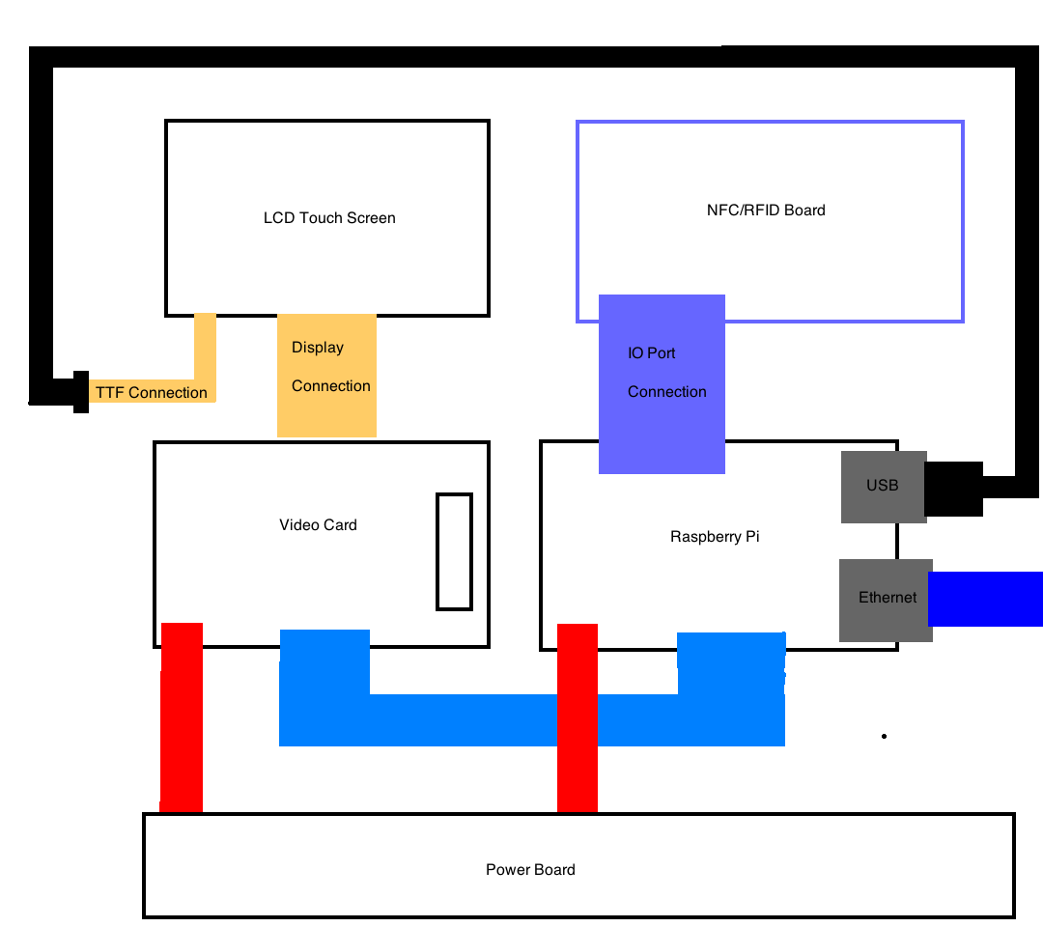  
IPO Chart

|  |  |  |
| --- | --- | --- |
| Input | Process | Output |
| Student ID | Log in (Student) | Boolean Value |
| Admin ID | Log in (Admin) | Boolean Value |
| Invalid ID | Login (Student) | Boolean Value |
| User Input, Student ID | Check Calendar | Calendar |
| User Input, Admin ID | Get Raw Data | Raw Data |
| User Input, Admin ID | Shutdown | Null |
| User Input, Admin ID | Exit | Null |
| User Input, Admin ID | Trouble Shooting | Trouble Shooting List |

Social and Ethical Issues

The social and ethical issues attached to this project are few and far between but those that are present are extremely important. To start with although offensive language was a very small problem, if I had not worried about it, it could’ve caused a very large problem; Fortunately for myself, in designing this project, I have discovered that very little content needs to be authored by myself for the project as all other data comes directly from an online system such as Edumate for example. Edumate being a software that is not only a real world entity, but also endorsed by the school, means that I do not have to worry about the data coming out of it being a social or ethical issue. In saying this the material I have to author is not null and I do still have to write a troubleshooting page that needs to be thorough and to the point, helping any administrator that needs to reboot, exit, or get the raw data for and from the system respectively. Exterior to this there are physical social and ethical issues that must be addressed. For example amputees, blind people and people with other disabilities have no way of tapping on and off their card without help. To solve this there could be allowances for height or the assumption that a person would help said amputee to tap on and off their card. Another of these physical issues is identity fraud. It is very easy to take someone else card and tap on or take two peoples cards and tap on for your friend who is not at school. This issue is not as simple to solve but a temporary solution that I have implemented is to have a member of staff standing at the device making sure this does not happen. In a similar fashion if someone forgets their card there is no way for them to sign in as present for school. It was suggested to me that this problem could be circumvented by implementing a biometric authentication system, but without the proper interfaces in terms of software and hardware in the future I plan on implementing a much more simple solution that involves the member of staff that is supervising the device typing in the name of the student after tapping their admin card. Overall there are a few social and ethical issues but I believe I have given solutions for the

Storyboard

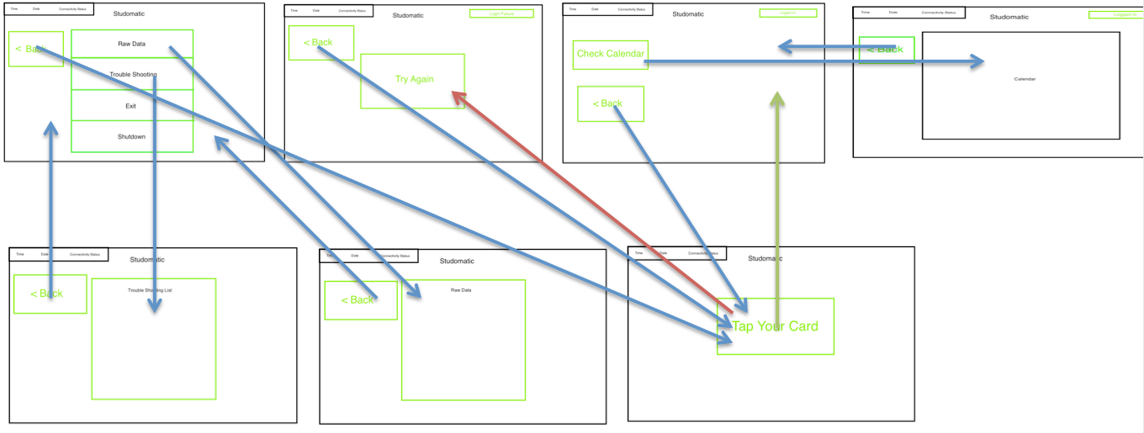

Test Data & Expected Output

|  |  |
| --- | --- |
| **Input** | **Output** |
| User 1 Taps on | Logged in Message Displayed  (Storyboard 2 Success) |
| User 1 Accesses Calendar | Calendar Displayed  (Storyboard 4) |
| Invalid User Taps on | Could Not Log in Message Displayed  (Storyboard 2 Failure) |
| Admin User Taps on | Admin Screen Displayed  (Storyboard 2 Admin) |
| Admin User Accesses Troubleshooting page | Troubleshooting list Displayed  (Storyboard 5) |
| Admin User Accesses Raw Data page | Raw Data Page Displayed  (Storyboard 6) |
| Admin User Accesses Calendar | Calendar Displayed  (Storyboard 4) |
| Admin User Exits Application | N/A |
| Admin User Shuts down System | N/A |
| Admin User Closes Admin Page | Login Page Displayed  (Storyboard 1) |
| User 2 Taps on | Logged in Message Displayed  (Storyboard 2 Success) |

DFD

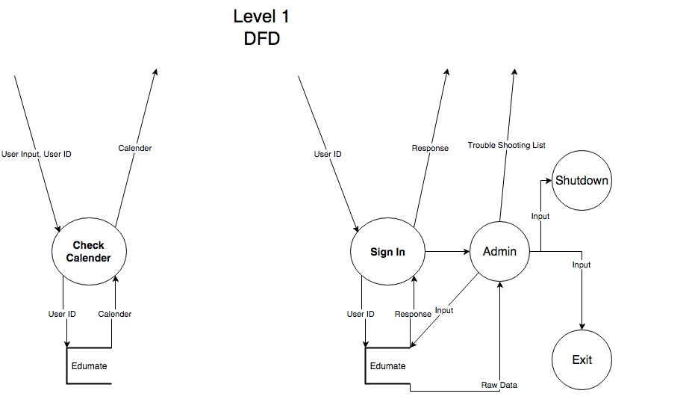

System Flowchart

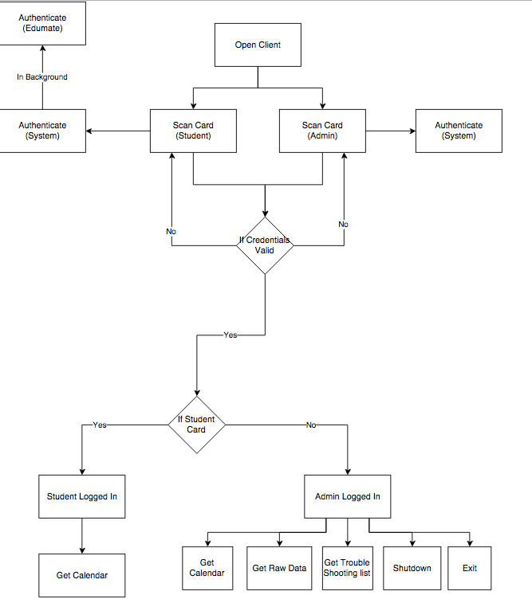

Structure Chart

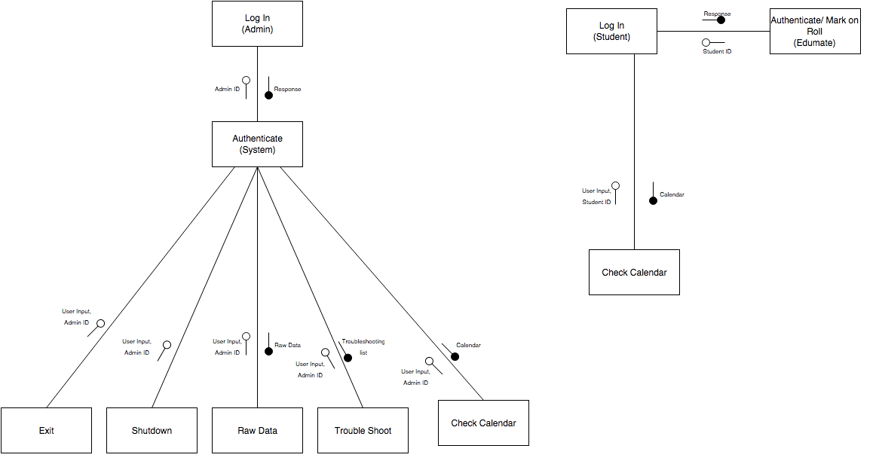

Context Diagram

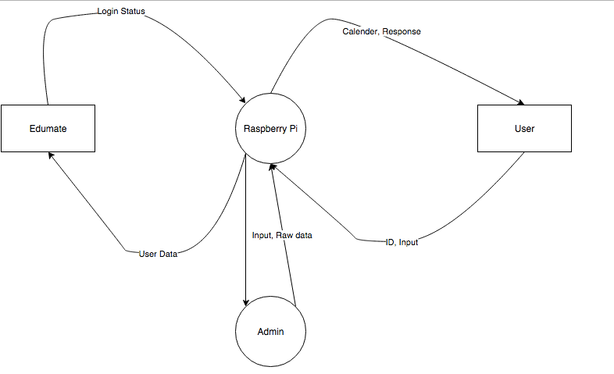

Reflection

When looking at my project from a holistic perspective it is plain to see that, so far, it has gone off without a hitch. Without being slightly too optimistic I believe I can say that most of my projects do go like this but this one in particular has been extremely easy up until this point. I have been able to complete most of the documentation quickly, with ease and to the best of my ability having a very good understanding of this part of this course and of the design of my project. Factors that have contributed to some of my project being harder than it should be include, but are not limited to:

* Java not being installed on my computer
* Other assessment tasks infringing on my SDD time
* Having to do SDD homework
* IT blocking all useful functionality of the internet and my computer

Although these problems may not seem to have affected my project I can say with relative certainty my work ethic and problem solving have erased all evidence of them. In terms of the hardest parts of my documentation I think the pieces we hadn’t been taught to do, or had at any point done before were the hardest for obvious reasons. These were:

* Quality Assurance
* Test Data & Expected Output
* Social and Ethical Issues

For obvious reasons, not having done this before made it a lot harder to complete these. As such I believe these are where I will lose any marks as well as some silly mistakes and oversights in terms of design. Another extremely important thing to note at this point is the Internet and moving houses. In the duration of the project I moved houses, which made it exceedingly hard to continue my project log and my documentation, which is reflected in some of my documentation but honestly in the long run did not make much difference overall. A much more influential problem was my lack of internet. Some how in the week leading up to this part of the projects due date our schools IT department managed to break the SSL certificates on our computers, completely eradicating any useful function of our computers Wi-FI cards. This forced me to move from computer, in terms of research for my project, to books making it a lot harder to transcribe and taking a lot more time. To expand on a similar issue that I raised before, the lack of Java on my computer, which also forced me to move from computer paper I would like to pose an analogy. Doing a Gantt Chart on paper is like painting the Mona Lisa in invisible ink, extremely un-satisfying and horribly hard.

In conclusion I can say that my project was very well executed with little to no interruptions and/or problems and I am looking forward to the rest of my project going a similar way.